Welcome to our Nursery

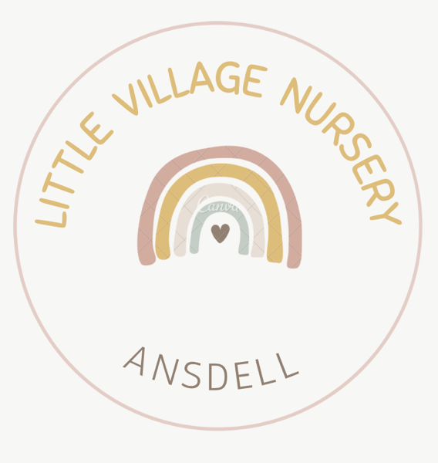

This pack forms all the information we would like to share with new families about our setting

Please complete the forms and return to nursery

Contact information

01253 732416
Contactus@littlevillagenursery.info

Your nursery manager is : Holly Quine

Your deputy manager is : Holly Falconer

Your designated safeguarding leads are: Holly Quine, Holly Falconer and Caragh Leeson

The Nursery SENCO is : Holly Quine

Welcome to Little Village Nursery

We hope that this information helps you to settle into our nursery family and help to manage expectations for learning and development along with general information about our nursery.

The nursery is a family owned and run setting, we have two other settings in the family also. Our ethos is to provide the standard of care the family would expect for our own children.
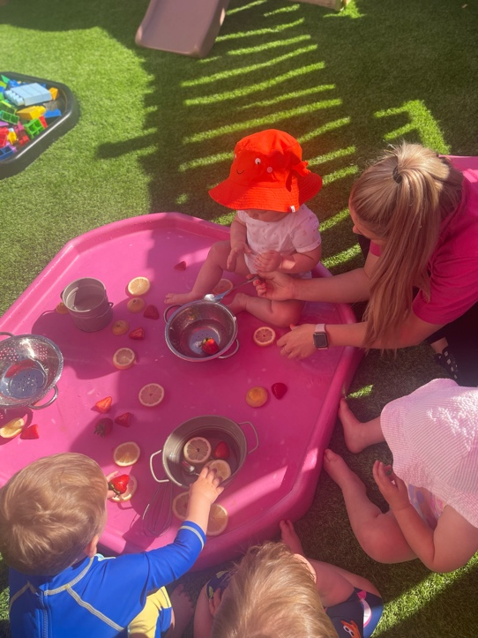
We do this by creating a home from home environment to help children settle into a comfortable setting where they feel safe and secure to play and learn at their own pace.

Settling in

Once parents have chosen our setting for their little ones, the manager will have a catch up to see how you feel would be the best way to settle your child. You know them best and so we will work at your pace by having as many or as few settle in sessions as you need, to make sure both you and your family are happy before your child’s first day.

The sessions range from 30 minutes to an hour and will usually be arranged for days that your key worker will be in to help the settling in process. During the sessions we may ask for you to leave your child with us after a while to simulate a normal nursery session. Please bring anything that your child may need such as a comforter, dummy, or special toy. Plus a bag with nappies and a change of clothes.

Communication- parents as partners

Our nursery uses an app called Famly. Once we receive your registration forms back we will create you an account where you can access your child’s daily log including meals and sleeping to nappy changes.

Famly includes a feature that enables parents to send a message to your key worker and management at anytime. You can see when your child is signed in and out, access learning and development records, picture updates of your child and also make payment and receive invoices.

We also use the newsfeed to update you on events at nursery, pass messages across to parents and allow you to upload pictures from home to ensure there is a consistent continuation of learning between home and nursery.

You can add as many contacts as you like to your child’s account and include pictures to help us with safety checks should you allow designated people to collect your child. There is a section for this in your registration pack also. If your child will not be attending nursery for their session there is a section for parents to log this as a sickness or absence along with a reason for our records.

Our team

Our team are all qualified at level 3 or studying towards level 3. We have team members who are level 6 and Early Years Teacher status.
When choosing our team members we are careful to take time and make sure that they are the right fit for our nursery family whilst undergoing DBS and reference checks before any contact with the children. All of our team share our passion for making sure that we provide the best for our children combined with a calm and caring nature to provide emotional support when needed for your child.

team members are first aid, allergy, food hygiene trained. We also continually update our knowledge using our noodlenow platform, a training program with over 100 courses updated regularly paid for by the company for our staff to access anytime. We also take part in our local council courses to keep knowledge and experiences for the children fresh and exciting.

Our Staff

Management
Area Manager: | Jade Mulligan
Nursery Manager : | Holly Quine
Deputy Manager : | Holly Falconer
Supervisor : | Caragh Leeson
Baby Team
 | Caragh Leeson
 | Megan McAfee
Toddler Team
 | Ellie England
 | Ellie Lloyd-Walden
Pre-School Team
 | Olivia Leader
 | Dani Andrews
 | Emily Pass
Regular Visitors
Bilinuasing | Cath holds our weekly Spanish sessions

The Early Years Foundation Stage 2021 (EYFS)

You may see this around the setting or on your child’s assessments. The EYFS is the framework that outlines the learning and development, assessment, safeguarding and welfare requirements that early years providers must meet to ensure that your children are learning and developing whilst being kept healthy and safe. We are inspected by Ofsted to ensure compliance with these requirements.

Learning and development
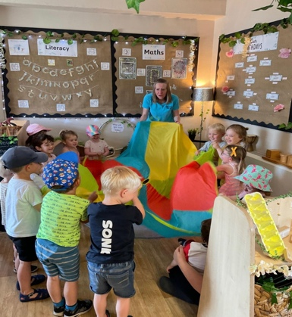
Our team will observe children in various ways, during their play and interactions with others, planned learning time and adult lead activities. We understand that you will have already made a start on your child’s learning journey at home and so we want to understand from you where your child is up to. Along with our observations and yours, your child’s key worker will consider how best to deepen and strengthen their current learning, development and next steps.

Parents will receive updates on their news feed while your child is at nursery with us we call this a ‘post’. Once a developmental milestone is reached your key worker will write an observation to document this. At the end of each term your child will receive an assessment which will help us to track your child’s development and identify any areas that we may need to support your child further.

These will all be shared through our famly app and you will receive a notification each time something is published for your child
.
We will also hold regular parents evenings and stay and play sessions where you can talk to your key worker about your child’s development.

We encourage parental input at nursery and so would benefit from parents sharing pictures or updates with us via famly from home. Your key worker will use any information and updates from home during their planning for your child alongside their observations and the views of the children.

Our Vision
What do we provide for families at our setting?

- Emotionally confident and happy children
- Children who feel safe, supported and cared for
- Children who are making progress with their developmental milestones
- Parents who feel involved in their child’s nursery journey
- Practitioners who key into interests and develop their rooms to reflect these and further learning.

Our Curriculum
Children follow the Early Years Foundation Stage Curriculum, which consists of seven areas of learning.

Prime areas
- Communication and Language
- Personal Social and emotional development
- Physical Development

Specific areas
- Mathematics
- Literacy
- Understanding the world
- Expressive arts and design

We teach children by ensuring challenging, playful opportunities across both the prime and specific areas of learning. We recognise that all children develop and learn at different rates and so our EYFS curriculum is designed flexibly to meet the needs of all individuals. We support individual learning through our skilful interactions and observations which lead to detailed next step planning.

The Characteristics of Effective Learning underpin our curriculum and children’s learning, through an enabling and well-planned environment we ensure we provide meaningful opportunities for:
- playing and learning,
- active learning,
- creating and thinking critically.

As children utilise and develop these characteristics they become effective and motivated learners who demonstrate high levels of well-being and involvement.

Our environments

“Continuous Provision” is how we plan our learning environment. The purpose of continuous provision is "to continue the provision for learning independently". Each and every part of our learning environment has been carefully planned to meet and challenge the development needs of our children.
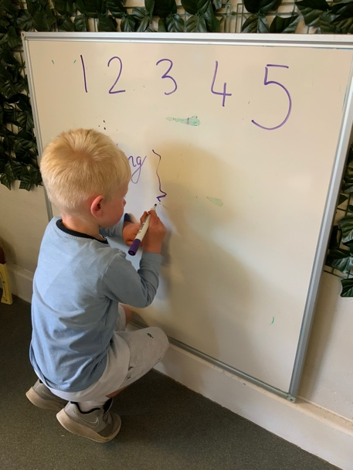
Learning opportunities are carefully planned around the interests of the children so they can lead, take ownership and become immersed in their learning. We support the children to develop their skills progressively in exciting, fun and creative ways to achieve the highest standards possible. We also provide enhancements to areas and 'scenarios' to support their ideas and to really engage the children in their new learning experiences.

As well as our indoor provision our outdoor provision provides varied and exciting experiences. This includes mud kitchen, allotment and access to a well planned outdoor space which offers the children those experiences only available in the natural world.

We recognise that the environment plays a significant role in supporting children’s learning and development and so our indoor and outdoor spaces are designed to promote high levels of involvement and the level of learning.

Well-planned, high-quality continuous provision provides for children with familiar and consistent areas and resources that are open ended and flexible, promoting all aspects of learning and development.
We provide stimulating and challenging enhancements that give children new experiences and support new learning.

To enable children to participate in “risky freedoms” we ensure that both adults and children are involved in l
processes of assessing risk/ benefit.

Our environments are created to reflect and respond to children’s predictable and specific needs and interests

.
Special educational need and disabilities (SEND)

In order to support all the children in our setting we have a designated SENCO special educational needs Co-ordinator.
It is hoped that upon registering at nursery we can collect all the necessary information we need to enable us to put a plan in place and support all children. This may require an additional meeting with any professionals involved and parents to ensure a smooth and successful start to nursery.
As part of the role the SENCO supports key workers where children may not appear to be reaching milestones or progress gives cause for concern.
At such an early age a delay in development may not indicate SEN, however it is important we rule out other factors such as hearing or speech difficulties. The SENCO along with yourself will make observations and determine if there would be a need for additional support from other professionals such as the health visitor who can provide us with additional assessment. We do this in the hope that early identification and intervention will help to overcome future barriers to learning.

General information
Opening hours and sessions
Morning Session | 7:30am-1:00pm | £34.50 (0-2 years) £33.96 (3-4 years)
Afternoon Session | 1:00pm -5:45pm | £33.37 (0-2 years) £32.88 (3-4 years)
Full Day | 7:30am-5:45pm | £61.83 (0-2 years) £59.45 (3-4 years)
Funded Only | 9am-3pm | £5 for meals or bring a packed lunch

Sun Safety

We are proud to be a sun safe accredited setting, this means we have taken additional steps to make sure that our staff are trained to understand UV levels and the safety precautions needed to keep children safe during warm weather. We also have a sun safe monitor who informs each team the uv levels and heat expectations to allow us to prepare ahead of time
.
Nursery provides a factor 50 suncream that is applied regularly throughout the day. If you wish to send your own suncream into nursery we ask that you please clearly mark your child’s name on the bottle and that it is sent into nursery to stay with us. We also ask that each child has a named sun hat which is sent to nursery and stays with us to ensure we have adequate protection for the children at all times.

Nursery Meals

Upon arrival to Nursery we will offer your child breakfast, this varies each day and will be a selection of fresh fruit cereals crumpets, croissants, toast. We will also offer the option for a drink of milk or water.

Our lunch menu is available upon request or menu works on a three weekly rotor and is designed to support our healthy eating policy with balanced nutrition for our children.

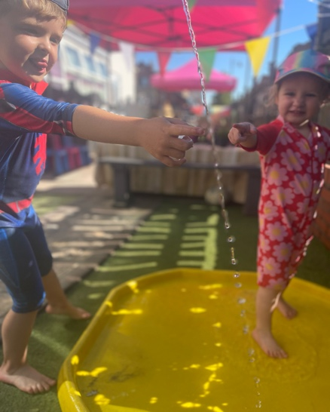
In the afternoon the children are offered a snack which is a fruit platter along with raisins or crackers. Children are offered a drink at night with a snack.

At 4 o’clock the children are offered a light tea this is designed to bridge the gap between snack and a meal that the children share with their family at home in the evening. Light tea will usually consist of sandwiches, soup, chicken goujons and beans.

Nursery meals are included in the price of a nursery session where children are funded only they have the opportunity to bring a packed lunch and their own snacks or for a small additional cost they may purchase Nursery meals.

Medication

We ensure and promote good health of all children in the setting.
While it is not our policy to care for sick children who should be at home, we will agree to administer prescribed medication as part of maintaining their health and well-being when they are recovering from illness and had suitable recuperation time at home.
Parents must give permission prior to administration of medication. When a child is brought in with medication, a senior member of staff will create a medication form on our famly app which will alert parents via notification.
Senior staff members can only administer medication once the parent has acknowledged the form and so it is important that if your child requires medication at nursery that you acknowledge the form as soon as possible.
Each time a child is administered medication at Nursery it is recorded and counter witnessed by senior members of the team on the Famly app.

Nursery uniform

It is not compulsory for children to wear uniform at nursery however we do have on offer polo shirts and T-shirts for £13 each at the office.

Belongings
Each day your child attends we request that you send a bag with a change of clothes and underwear and a suitable change of shoes for example wellies where necessary.

We request that a sun hat stay at Nursery along with a suncream if you require a different one to the cream that Nursery provides. We request that children bring unnamed water bottle to place on our hydration station to ensure that children have access to water whenever they would like throughout the day.
We ask that children do not bring toys from home after the initial settling in process as these may become lost or broken which can be upsetting to children, these also may contain smaller parts which could possibly could be a choking hazard to our younger children.

Child protection and safeguarding

Nursery is committed to promoting the welfare and safeguarding of all our children.
We expect all staff, parents and volunteers to share this commitment. The nursery follows Lancashire County Council child protection policy and procedures.
These policies are available for parents on request and can.
Please make sure that an adult always brings and collect your child, this must be someone over the age of 16.

If a different adult is collecting your child, please inform a member of staff as we do not allow children to leave the nurse with adults who we do not know.
You will be asked for a security password which enables the safety of your child as part of the admission pack any different adult collecting your child may be asked for this password and we asked that you sent us a photograph of them via our family app for additional security any questions when collecting a parent will always be called and the person collecting will be asked to remain outside of the nursery until confirmation is received from the parent or guardian.

Fees and free hours

Some two year olds and all three and four year olds are entitled to funding. Your nursery manager will be happy to help you with additional information. You can also check your eligibility on :

https://www.childcarechoices.gov.uk/

Data protection

Nursery is fully GDPR compliant. Our GDPR policy Is a available for parents on request.

Registration Pack
Collection Password

Please return once complete
Child’s First Name
Date of Birth

Surname
Address
Middle Name

Child Details

Post Code
Place of work
First Name
Date of Birth

Surname
Address
Middle Name

Parent/Guardian Details

Post Code

Email

Mobile Number
Home Number

Work Number
National Insurance No

Relationship to child

Who lives at this address?

With who does the child normally reside?
Place of work
First Name
Date of Birth

Surname
Address
Middle Name

Parent/Guardian Details

Post Code

Email

Mobile Number
Home Number

Work Number
National Insurance No

Relationship to child

Who lives at this address?

Are there any other professionals involved with your family?
(Health visitor, social worker, CP plans etc)

Name and Address of your child’s GP

First Name

Surname
Address
Authorised people to collect
Please give authorised people your password

Post Code

Email

Mobile Number
Home Number
Relationship to child

First Name

Surname
Address
Authorised people to collect
Please give authorised people your password

Post Code

Email

Mobile Number
Home Number
Relationship to child

Allergy information and dietary requirements
Does your child have an allergy to any of the following? Is there any of the following foods your child is not allowed to eat?
Bananas | YES / NO | Oranges | YES / NO
Beef | YES / NO | Penicillin | YES / NO
Butter | YES / NO | Pollen | YES / NO
Cotton wool | YES / NO | Pork | YES / NO
Cow’s milk | YES / NO | Soap powder | YES / NO
Eggs | YES / NO | Soya | YES / NO
Fish | YES / NO | Strawberries | YES / NO
Lactose | YES / NO | Sugar | YES / NO
Lamb | YES / NO | Wheat | YES / NO
Nuts | YES / NO | Dairy products | YES / NO
Vegan? | YES / NO | Vegetarian | YES / NO
We will make every effort to accommodate allergies but we cannot guarantee that food will not contain traces of known allergens.
Medical
Does your child have any of the following?
Asthma | YES / NO | Eczema | YES / NO
Diabetes | YES / NO | Febrile convulsions | YES / NO
Downs Syndrome | YES / NO | Hernia | YES / NO
Eye problems | YES / NO | Pyloric Stenosis | YES / NO
Grommets | YES / NO | Sensitive skin | YES / NO
Cleft lip | YES / NO | Hay fever | YES / NO
Injections
Has your child had the following injections?
Measles | YES / NO | Diphtheria | YES / NO
HIB | YES / NO | Meningitis C | YES / NO
MMR | YES / NO | Mumps | YES / NO
Polio | YES / NO | Rubella | YES / NO
Tetanus | YES / NO | Whooping cough | YES / NO
Covid 19 | YES / NO
Permissions
Can your child have / do the following?
Calpol / Calgel | YES / NO | Baby bath | YES / NO
Emg medical attention | YES / NO | Hair washed | YES / NO
Medication | YES / NO | Nails cut | YES / NO
Nappy cream | YES / NO | Vaseline | YES / NO
Sun cream | YES / NO | Go on outings | YES / NO
Have photos taken for observations on Famly and in the setting | YES / NO | Photos during shows and events | YES / NO
Use photos on social media | YES / NO | Using tools in forest school | YES / NO
Use the nursery minibus | YES / NO | Read child protection policy | YES / NO

Parent Signatures

Statement | Signature | Print name | Date
I confirm the the information in this registration pack is correct and give permission for my child for the specified allergens, medical information and permissions

Statement | Signature | Print name | Date
I understand that you will use my email & phone number for correspondence for anything relating to nursery communication eg newsletters and billing
I understand that any information that the nursery requires to have about my child will be held securely until the child reaches the age of 21 years and 6 months
I understand that if I have agreed for my child’s photo to be taken and used in any form of marketing that these photos will continue to be used after my child has left the setting
I understand that if there is a change in any of the details outlined on this form, I will ensure the nursery staff are informed. I understand how important it is to keep the information the nursery has for my child is up to date.
I understand that should there be any reason for concern nursery will contact the relevant services.

Parent Contract

Agreement to Terms and Conditions

Please take the time to read our parent pack before signing this agreement.
If you have any questions please do not hesitate to contact the nursery and we will be pleased to help.
Declaration of Acceptance

- I have read the parent pack and I am satisfied with the contents
- I understand that fees must be paid on the first day of my child’s week, or the first day of the month. Late payments will incur a strict 10% surcharge.
- I understand that if payments are made late that my child’s place is not guaranteed to be reserved.
- I agree to pay one month’s full fees following the first month of informing the nursery of a decision to terminate my contract. Fees will be paid in full before my child leaves.
- I agree to pay for days where nursery closes for all Bank Holidays.
- I understand that full fees are still to be paid in the event of sickness or family holidays.
- I agree to inform the nursery of any illness my child may have.
- I agree to inform the nursery of any changes to my contact details or details of authorised persons to collect my child.
- I agree to be bound to these terms.

CHILD’S NAME…………………………..............................

PARENT/CARER SIGNATURE……………………………....

PRINT NAME…………………………....................................

RELATIONSHIP TO CHILD…………………………..............

DATE………………………..

To keep our standards high, please tell us where you heard about us …………………………………………………………………………………………………………………………………………………………………………………………………………………………………....

Reason for your decision………………………………………………………………………………………………………

Last Updated 2022 JM- Area Manager

Information about your child

Take some time to complete this form.
If you would prefer to complete this form with a member of the nursery staff they will be happy to make an appointment to do so.
Date completed
Name of child |  |  |  |  | Date of birth
Toileting
 | Is your child in nappies (day/ night)?
 | Potty trained?
 | Toilet trained?
 | How much support do they require?
 | What additional resources do they require (eg toilet seat)?
 | Able to wash own hands?
Language
 | Please provide information on your child’s language skills. If they have some “individual” words, please note them down and what they mean.
 | Is English spoken at home?
If not what language(s) are spoken?
How Would you describe your child’s ethnicity or cultural background?
What is the main family religion?
Are there any festivals or special occasions in your culture that your child will be taking part in and that you would like to see acknowledged and celebrated whilst he/she attends nursery?
Likes
 | What activities does your child enjoy doing?
 | What toys do they like?
 | How would you describe your child, EG, shy, happy, confident.
Dislikes
 | What does your child not like doing (eg some children don’t like messy play and getting their hands dirty)?

How do you comfort your child when they are tired or distressed?
Routines
 | Does your child have a regular routine (if yes please provide details)?
 | Sleep
 | Meals
 | Snacks
(We will make every effort to accommodate your child’s routine into ours where possible.)
Does your child need a dummy for sleeping/when they are resting?
Does your child have a comforter of any kind?
Feeding:
 | Is your child on solid food?
 | Milk from a bottle/cup?
 | TYPE OF MILK (e.g. which formula or cows milk)
 | Food likes
 | Food dislikes
Is your child able to feed himself or herself independently?
What support does he or she require?
Known allergies in detail (more to follow) |  | We will make every effort to accommodate alleriges but we cannot guarantee that food will not contain traces of known allergens.
Medication

(you will need to complete a permission form via famly if you require us to administer any form of medication)
Any other information you wish to share with us

