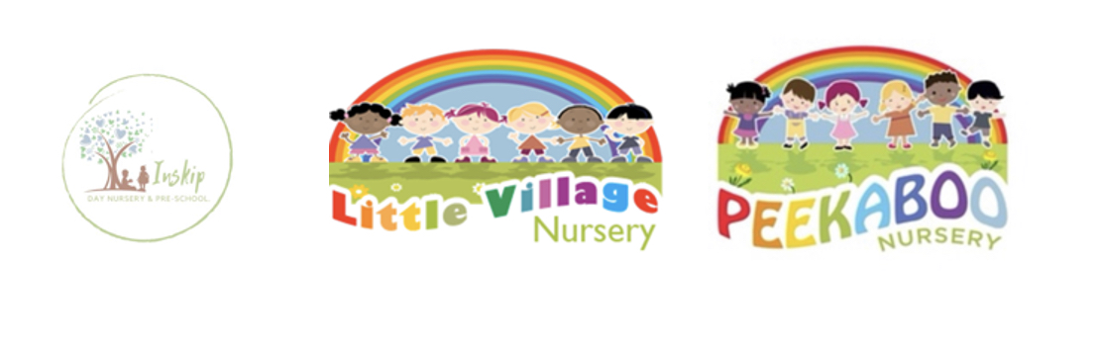
Behaviour Management Policy

Children and adults flourish best in a positive environment in which everyone knows what is expected of them and children are free to develop their play and learning without fear of being hurt or hindered by anyone else.
We understand the critical role adults have in modelling behaviour and therefore we consistently encourage positive behaviour that promotes children’s welfare and development.
We aim to work towards a situation in which children can develop their independence, self-discipline and self-esteem in an atmosphere of mutual respect and encouragement. We allow children to flourish, learn and make a positive contribution.

In order to achieve this, all the staff, as early years practitioners:
- Act as good role models;
- Use praise and positive reinforcement;
- Praise group behaviour as well as individual;
- Use positively phrased sentences when guiding children on what is expected of them;
- Encourage sharing and negotiation;
- Ensure that the rules are applied consistently, so that children have the security of knowing what to expect and can build up useful habits of behaviour;
- Provide a positive role model for the children with regard to friendliness, care and courtesy;
- Praise and endorse desirable behaviour such as kindness and willingness to share;
- Consult with the children when creating boundaries and rules;
- Help children understand the consequences of their behaviour;

- Help children challenge bullying, harassment and name-calling;

- Encourage children to be responsible, for example tidying up and pouring their own drinks;

- Reassure children they are valued as individuals even if their behaviour is sometimes unacceptable;

- Take positive steps to avoid a situation in which children receive adult attention only in return for undesirable behaviour;

- Create a positive and stimulating environment with age appropriate and challenging activities;

- Give one to one adult support to children who misbehave to understand what was wrong and work towards a better pattern of behaviour;

- Will always make it clear to the child or children who are misbehaving, that it is the behaviour and not the child that is unwelcome or undesired;

- Will not humiliate, segregate, withhold food or use a ‘naughty chair’ in managing children’s behaviour, as this is detrimental to their self esteem;

- Will not shout, or raise our voices in a threatening way;

- Will neither use or threaten physical punishment, such as smacking or shaking;

- Will handle any behaviour problems in a developmentally appropriate fashion, respecting individual children’s level of understanding and maturity;

- Will tackle recurring problems on a whole basis, in partnership with the child’s parents, using objective observation records to establish an understanding of the cause or analyse possible triggers.

- Are aware that some kinds of behaviour may arise from a child’s special needs;

- Will where possible, ignore unwanted behaviour and focus on praising the wanted behaviour instead;

- Will allow children to move away to a quieter area to calm down. Once calm we talk to the child about their behaviour and listen to what the child has to say;

- Support children to learn ways to deal with their feelings;
- Understand that rewards are much more effective than sanctions;
- Do not use any form of physical intervention unless it is necessary to prevent personal injury to the child, other children, an adult or serious damage to property;
- Will record any incidents where physical intervention is used.

Physical Intervention Procedure We follow the Physical Handling in Early Years guidance provided by OFSTED. We record incidents on the Famly App for Physical intervention and recordable written statement from all employees involved and or witnesses recording the following details:
- The name of the child
- The name of the staff member(s) who used physical intervention
- Previous intervention techniques used prior to the incident
- The date, time and place of the incident
- The circumstances of the incident and the factors leading up to the incident
- The nature of the physical intervention used
- The names of any witnesses
- Any injuries that may have occurred during the incident
- Any further action taken and parents’ signatures. Where physical intervention is used to manage a child’s behaviour this is recorded and the parent/ carers is informed on the same day. This information is then stored in the office. Parents are invited into the classroom to tell them about the incident and sign the form.

Our Behaviour Management Officer is Your Manager. They is responsible for behaviour management, for supporting and sharing information with other staff, accessing expert advice and involving parents in the review of this policy.

Parents/carers are included in making joint decisions about their child. We share information with parents/carers about their child’s behaviour.
An action behaviour plan is created to deal with a child’s unacceptable behaviour.
In extreme circumstances, we consult with external agencies, making sure parents are asked for consent before agencies are approached.
We do not tolerate any form of bullying by either a member of staff, child or parent.
Our staff will not tolerate physical or verbal abuse or intimidation from parents.
All staff have read and understood the behaviour management policy during their induction process, and are consistent in the use of techniques to encourage positive behaviour and consistent in the use of intervention techniques.

Intervention techniques
Structuring the environment Where we choose to speak to the child and whether we sit or stand can communicate the nature of the discussion, and may help the child to modify their own behaviour, for example, warm and friendly or cold and business-like.
Planned ignoring By not giving the attention to minor, harmless, attention-seeking behaviour, these behaviours are likely to die out. Remember, it is equally important to praise appropriate behaviour.
Prompting Gentle reminders to a child of what they need to stop doing or prepare for, can help the child to adjust to a change. This can be verbal or sensory input. Be careful to avoid ‘nagging’ the child.
Active listening Sometimes listening to what the child has to say and exploring and acknowledging their feelings through the use of reflective response can help a child to feel that:
- Someone else acknowledges the reality of their feelings;
- They are not alone
- Someone cares Sometimes this can be enough for a child to stay in control.

Interpretation and interference Verbalise what has happened and ask the child if there was another way that they could have acted. For example, “it looked like you were really upset before you hit Johnny – was there another way you could have let him know how upset you were.”

Backing away
This is not the same as backing down. You are not giving the child time to calm down before you discuss the situation with them. Staying and continuing to challenge someone who is already angry is likely to make the situation worse. Alternatively, allow the child to back away through offering them a verbal or physical way out.
Affection If a child’s behaviour is motivated by fear, anxiety or uncertainty, a big injection of affection – verbal or physical – can help head off inappropriate behaviour. Children do not always appreciate the care that is provided for them on a daily basis and need additional affection to understand how much the adults really care for them.

Hurdle help Where the child is stuck, providing assistance can help overcome feelings of failure or inadequacy.
Proximity Sometimes an adult quietly heading in the general direction of what is going on can be enough to encourage children to do something else.
Involvement and interest Adults becoming involved in a situation can diffuse things. Redirecting/distracting Trying to refocus the child away from what they are doing now, on to something else as a way of avoiding trouble.
Directive statement/direct appeal A clear instruction to the child to stop certain behaviours or start something else.

Distraction
Asking children to move away to another or quieter area to play and calm down. This should only be used if the adult will use the distraction method to talk to the child about their behaviour once they’ve calmed down. It is not a helpful method to encourage positive behaviour, it should not be used for isolation purposes only.

